**Salazar Hall Network Proposal**

By:

Esdras Solorzano

Bryan Tsang

Christopher Valdepena

Fausto Vidrio

Tues, Thurs class 12:15 - 1:30

Group 6

Prepared for:

3rd floor of Salazar Hall

Building 15A

California State University

**Table of Contents**

**Business Goals****………………………………………………………………………………... 3**

**Scope of the project………………………………………………………………………….. 4**

**Information on the Existing Network****……………………………………………………… 5**

**Information on New Applications****………………………………………………………….. 6**

**Technical Requirements****……………………………………………………………………... 7**

**Physical Design****……………………………………………………………………………….. 9**

**Logical Design****……………………………………………………………………………….. 10**

**Environmental or Architectural constraints…………………………………………….. 11**

**Preliminary Schedule****……………………………………………………………………….. 12**

**Legal and Contractual Terms and Conditions****………………………………………….. 13**

# 

# **Business Goals**

# **Background:** This proposal is for a California State University in Los Angeles. The goal for this proposal is to design an entire network for the 3rd floor of Salazar Hall Building 15A as well as providing increased productivity, student/teacher performance and improved workflow. The building has multiple classrooms, labs and an electrical room.

**Business Goals:** The network will be designed to achieve several operational objectives.

1. Secure Service: The main goal of this network is to provide secure administrative computing service to the 3rd floor of Salazar Hall Building 15A. It is designed to be functionally and physically isolated from access by people not going to school at Cal State La in order to minimize the risk of unauthorized use.
2. Integration and Update: Presently there is a network design at Cal State LA but much of the equipment is outdated. This proposal describes a network design that integrates and updates all equipment to the newest and best technology for example, all software applications will be the newest version (2021). There will be new modems, routers, switches, laptops, desktops, etc….
3. Versatile Information Processing: The network will enable users to retrieve, process, and store data regarding the operation of the students, teachers, and check in and check out of students being taught at the 3rd floor of Salazar Hall Building 15A.
4. Scalability: The network design is scalable so that more network cable equipment and computer equipment can be added if needed and as funding becomes available without having to redo the installed network. This will save time and be key to the years to come as the equipment becomes outdated.

**Scope of the Project**

**Network Scope:** The work that will be performed will include the design and installation of the new network design. This includes the installation and setup of all the network devices, cabling and interfaces which may include but may not be limited to workstations, multi-function devices, servers, switches, routers, racks, and all related software. The proposed network is designed to serve the 3rd floor of Salazar Hall Building 15A at Cal State La. The 3rd floor contains 11 classrooms, 11 laboratory rooms, 1 office and an electrical room which will all be served by this network. Each classroom will have 1 computer, each laboratory will have 30 computers and 1 printer except for lab room A366 which will have 10 computers. The equipment room will contain a modem, firewall, 32 or more switches, Cat 6 cables making up to 1GBPS, constant power supply and good cable management. Note that this network serves instructional needs of students and teachers. This network is also for administrative purposes and is specifically designed to be dependent on student computing facilities.

**Intended Users:** The primary users of the network at the 3rd floor of Salazar Hall Building 15A at Cal State La will be administrators, all students and all teachers.

**Design Assumptions:** Internet service is provided by California State University Los Angeles.

# 

# 

# 

# 

# 

# **Information on the Existing Network**

The existing network is in Salazar Hall third floor in California State University Of Los Angeles.

**Equipment Room**

The Equipment room we will be using would be in the electrical room. The room will be kept well ventilated and in a cool environment.

**In the Equipment Room:**

* Modem
* Firewall
* 32 or more switches
* Cat 6 cables making up to 1GBPS
* Constant power supply
* Good cable management

**Computer Lab**

The computer lab will consist of 11 work stations. 10 of the workstations will have a total of 30 personal computers. While one of the workstations will have a total of 10 personal computers.

**In computer lab:**

* 11 workstations
* Cat 6 cables
* One printer
* One pc for admins/network manager

# 

# **Information on New Applications**

Some computer labs will need to be updated with 2021 software and equipment so that students and faculty can complete their tasks and get familiar with new technology. With the impact of covid-19, computer lab resources will be used more. Therefore, we must upgrade to new and unique applications because students with different backgrounds will visit.

**New Computer Lab Equipment:**

MacBook Pro 13.3" Laptop - Apple M1 chip - 8GB Memory - 256GB SSD

Price $1,149.99

Vostro 5890 Desktop

Price $849.99

Apple - iPad mini (Latest Model) with Wi-Fi - 64GB - Space Gray

Price $499.99

JBL LIVE 500BT Wireless Over-Ear Headphones

Price $39.99

DGS-3130 Series 30-Port L2+ Fully Managed Gigabit PoE Switch

Price $978.99

Netgear Nighthawk AXE11000 Tri-Band WiFi 6E Router

Price $599.99

NEC NP-UM361X-WK Ultra Short Throw w/ Wall Mount Projector

Price: $1,245.00

**New Software/ Services:**

Windows 11

Adobe Photoshop Elements 2021

Microsoft azure

AutoCAD: 2D and 3D CAD software with design automation and industry-specific toolsets

NetSuite ERP System

AWS

McAfee Total Protection

# **Technical Requirements**

**Security requirements:**

We will be using a firewall so that any unauthorized user is restricted from joining the network. We will also include a password and username accounts for authorized users. As Well as a different administrative account for network managers

**Reliability Requirements:**

In keeping with user expectations and industry standards, both the LANs and the WAN are expected to operate at 99.9% uptime and an undiscovered error rate of .001%.

**Storage Requirements:**

The storage size must have a large enough size for students and staff faculty to use.

**Transmission speed Requirement:**

The network must be transparent to users.

**Users and Priorities:**

A max of 30 users on the network. Network managers gets priorities

**Requirements**

* **Software**
  + Microsoft Windows 10 on all workstations
  + Microsoft 365
  + Anti-virus
  + Vpn
* Printer, copy
* Switches
* Server
* Work stations
* Firewall
* Modem
* Router

# **Physical Design**

# 

# 

# **Logical Design**

# Computer lab room A346 (10 PCs total):

# 

# Other computer lab rooms (30 PCs total):

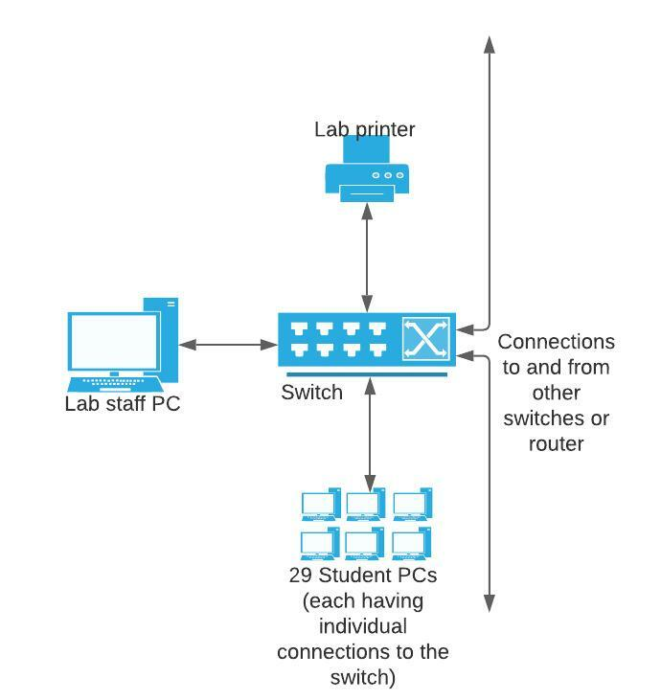

**Environmental or Architectural Constraints**

# 

# **CONSTRAINTS:**

# **Earthquake:** Which includes if an earthquake were to occur as it is likely to occur in Los Angeles. Buildings may collapse destroying the equipment room with the electrical wiring.

# **Fire hazard:** Can run into fire hazard from the electrical equipments

* **Legacy devices:** There may be valuable old devices
* **Switches:** Switches may not be of a fit
* **Wiring:** Fiber optic cable Cat 6

***EMERGENCY***

**If an earthquake, fire hazard or anything emergency related that may destroy the data, we will have a backup recovery plan. We will be backuping every data and schedule a weekly maintenance to insure everything is safe**

# 

# **Preliminary Schedule**

**Schedule goals:**

For the purpose of limiting the budget of the project and considering unexpected difficulties during the deployment of the project, the goal is to have the project finished in no longer than 14 days. Our aim is to have a smooth deployment without hindrance and have completion within the time frame.

**Week 1:**

Begin the project. Setup the router, modem, firewall, and server in the electrical room. Deploy all new equipment that will be integrated into the network. Setup and configure all necessary switches for the computer labs and classrooms. Begin establishing connections to all equipment via cat 6 ethernet cables. Setup and configure wireless access points in rooms A358 and 339.

**Week 2:**

Begin creating and configuring user accounts for the network. Obtain the necessary licenses to use the operating systems and software applications. Configure necessary network security settings and tools such as firewall, vpn, passwords, and anti-virus.

# **Legal and Contractual Terms and Conditions**

The terms and conditions of the Professional Services Agreement apply in full to the services and products provided under this Statement of Work.

IN WITNESS WHEREOF, the parties hereto each acting with proper authority have executed this Statement of Work, under seal.

California State University, Los Angeles Salazar Hall Network Proposal

_______________________________ ________________________________

Full name Full name

________________________________ ________________________________

Title Title

________________________________ ________________________________

Signature Signature

________________________________ ________________________________

Date Date